AI Assistant Coding
Assignment 1.2
Name : Thalla Aravind
Roll No : 2303A52049
Batch – 32

Task 1:
AI-Generated Logic Without Modularization (Factorial without Functions)
Scenario: You are building a small command-line utility for a startup intern onboarding task. The program is simple and must be written quickly without modular design.
Task Description: Use GitHub Copilot to generate a java program that computes a mathematical product-based value (factorial-like logic) directly in the main execution flow, without using any user-defined functions.
Constraint:
  - Do not define any custom function
  - Logic must be implemented using loops and variables only
Prompt :
Code:
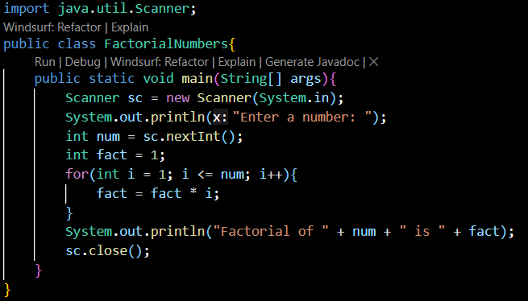

Output:

Explanation :
The code above is a Java program that calculates the factorial of a given number using loops and variables. It prompts the user to enter a number, then uses a for loop to multiply all integers from 1 to that number to compute the factorial, and finally prints the result.

Task 2:
AI Code Optimization & Cleanup (Improving Efficiency)
Scenario: Your team lead asks you to review AI-generated code before committing it to a shared repository.
Task Description : Analyze the code generated in Task 1 and use Copilot again to:
  - Reduce unnecessary variables
  - Improve loop clarity
  - Enhance readability and efficiency
Hint: Prompt Copilot with phrases like
“optimize this code”, “simplify logic”, or “make it more readable

Prompt:
Code :
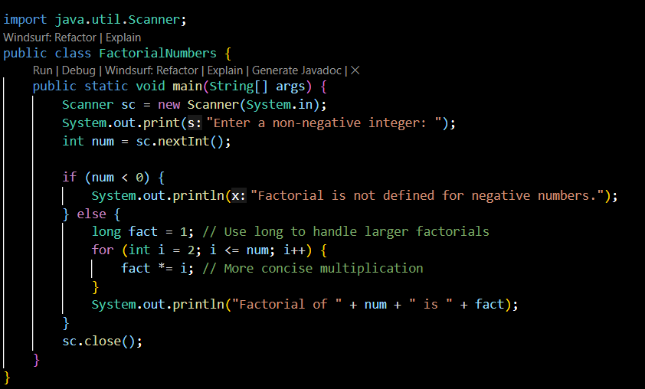

Output:
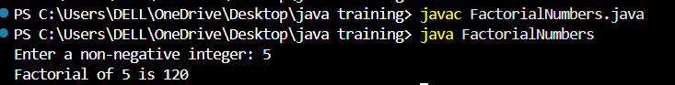
Explanation:
Compared to previous code this code was most efficient as it handles the edge case for negative and zero input and more readable code

Task 3:
Modular Design Using AI Assistance (Factorial with Functions)
Scenario: The same logic now needs to be reused in multiple scripts.
Task Description: Use GitHub Copilot to generate a modular version of the program by:
  - Creating a user-defined function
  - Calling the function from the main block
Constraints
  - Use meaningful function and variable names
  - Include inline comments (preferably suggested by Copilot)
Prompt :
Code :
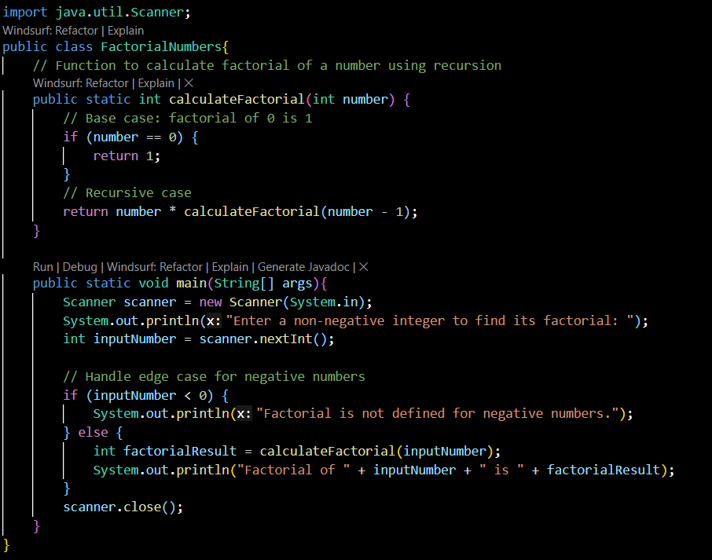

Output :
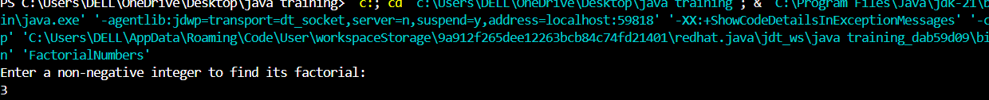

Explanation :
1. Meaningful Function Name: The function to calculate the factorial is named `calculateFactorial`, which clearly indicates its purpose.
2. Recursion: The factorial calculation is implemented using recursion, which is a more elegant approach for this problem.
3. Edge Case Handling: The program checks for negative input and provides a relevant message, ensuring robustness.
4. Clear Variable Names: Variables like `inputNumber` and `factorialResult` are used to enhance code readability.
5. Commented Code: The code is commented to explain its purpose and flow, making it easier to understand.

Task 4:
Comparative Analysis – Procedural vs Modular AI Code (With vs Without Functions)

Scenario
As part of a code review meeting, you are asked to justify design choices.
Task Description
Compare the non-function and function-based Copilot-generated programs on the following criteria:
  - Logic clarity
  - Reusability
  - Debugging ease
  - Suitability for large projects
  - AI dependency risk

Criteria | Functional Style (Recursive) |  | Non-Functional Style (Iterative)
Logic Clarity | Less clear for beginners (recursive thinking needed) |  | Very clear and intuitive
Readability | Short and mathematically expressive |  | Slightly longer but straightforward
Reusability | High (pure function, no side effects) |  | Moderate (depends on implementation)
Debugging Ease | Harder (deep call stack) |  | Easy (loop, step-by-step)
Performance | Slower (function call overhead) |  | Faster
Scalability (large n) | Stack overflow risk |  | Safe for large inputs
AI Dependency Risk | Higher (AI often generates recursion blindly) |  | Lower (explicit logic, human- m readable)
Task 5:
AI-Generated Iterative vs Recursive Thinking

Scenario: Your mentor wants to test how well AI understands different computational paradigms.
Task Description: Prompt Copilot to generate:
An iterative version of the logic
A recursive version of the same logic
Constraints :Both implementations must produce identical outputs
Students must not manually write the code first

- Expected Deliverables
Two AI-generated implementations
Execution flow explanation (in your own words)
Comparison covering:
  - Readability
  - Stack usage
  - Performance implications
When recursion is not recommended

Iterative Approach :
Prompt :
Code :

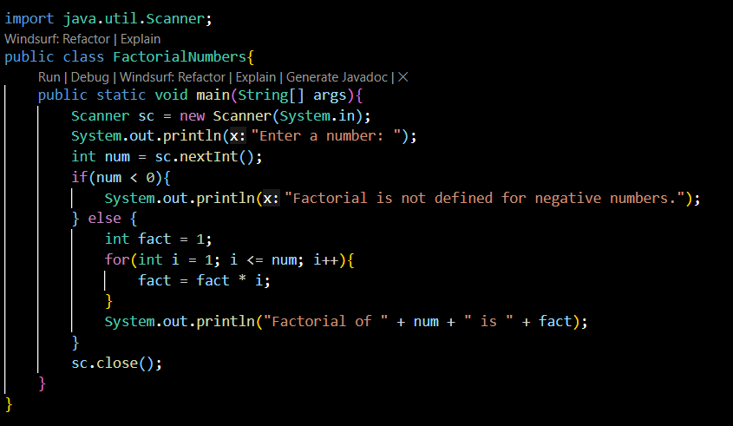
Output :
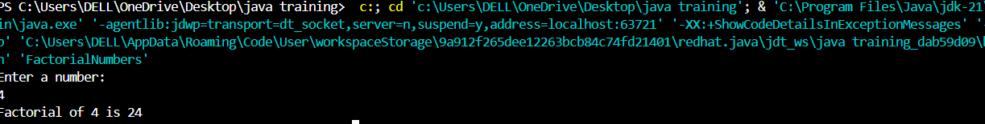

Recursive Approach:
Prompt :
Code :
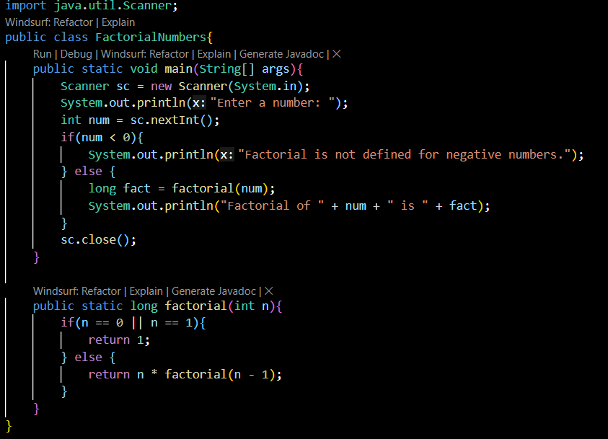
Output :
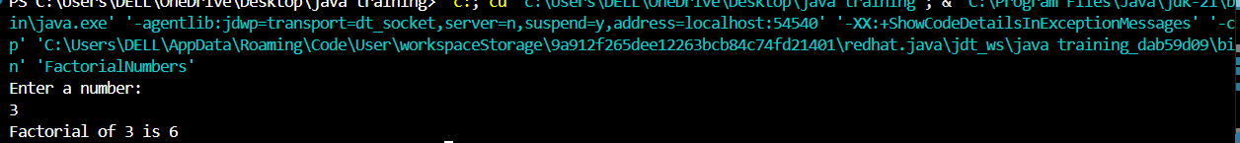

Iterative Approach vs Recursive Approach
Aspect | Iterative Approach | Recursive Approach
Readability | Easy to understand | Less intuitive
Stack Usage | No extra stack used | Uses call stack
Performance | Faster | Slower

